W-20

**YEAR 12 PHYSICS**

**ASSIGNMENT 2 - GRAVITATION**

**Name:** **Mark:**

1. Titan is the largest of Saturn’s moons. Its orbital radius is 1.22 × 106 km. Use the Formulae and Data booklet and the data in the table below to determine the strength of Saturn’s gravitational field where Titan orbits. Give your answer in Nkg−1 and ms−2. (5 marks)

|  |  |
| --- | --- |
| **Planet** | **Mass (Earth masses)** |
| Mercury | 0.055 |
| Venus | 0.815 |
| Earth | 1.000 |
| Mars | 0.107 |
| Jupiter | 318 |
| Saturn | 95 |
| Uranus | 14.5 |
| Neptune | 17.2 |
| Pluto | 0.002 |

Nkg-1

ms-2

2. When a satellite is launched it is placed in an initial circular orbit around the Earth. Later some small jets on board the satellite will fire compressed gas for a set period of time to move it to the precise final circular orbit required. These gas jets point backward relative to the satellite’s motion only and ***not*** toward or away from the Earth.

How can backward facing gas jets be used to raise the satellite to a higher final circular orbit? (4 marks)

3. A satellite orbits 4.22 × 107 m above the Earth’s centre. At a certain point in its orbit around the Earth, the satellite and the Moon line up as shown in the diagram below. Show that in this position the influence of the Moon on the satellite is negligible, compared with the influence of the Earth. (7 marks)

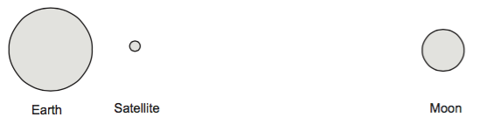

4. A GPS system uses the signals from four satellites to establish a position on the Earth’s surface. The satellites have an orbital period of 12.0 hours but they are in different planes of orbit. Each satellite has an atomic clock that allows a signal to be emitted at prescribed intervals. The time difference between the four signals is used by the receiver to establish a position.

(a) By equating the relationship for centripetal force and gravitational force, show that the orbital velocity of each satellite is close to 3.90 × 103 ms−1. Show all your workings. (5 marks)

(b) The manufacturers of the satellites deliberately build in a correction to the rate at which the clocks tick so that they run a little fast before they are put into orbit. Explain why they do this. (2 marks)

5. The Kepler NASA mission aims to search for planets orbiting stars in other solar systems. The star named Kepler-20 has been observed to have several planets orbiting it. Kepler 20 is 950 light-years from Earth.

Information about Kepler 20 and some of the planets orbiting it is summarised in the table below.

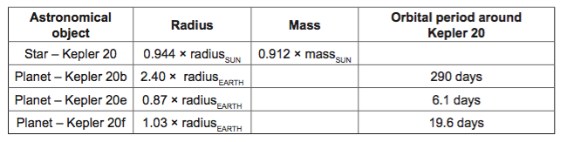

(a)   A light-year is an astronomical unit of distance. It is defined as the distance travelled by light in one year. Calculate the distance from Kepler 20 to Earth in kilometres.   (2 marks)

(b)   Astronomers express the mass of Kepler 20 as (0.912 ± 0.035) × massSUN. Calculate the maximum value astronomers expect for the mass of Kepler 20. (2 marks)

(c)   Calculate the orbital radius of Kepler 20e around Kepler 20. You should use the mass for Kepler 20 quoted in the table and assume the orbit is circular. (4 marks)

(d) The mass of Kepler 20b is unknown but it has been speculated that it may have a density similar to that of Earth, 5520 kgm-3. Calculate the surface gravity of Kepler 20b if its density is 5520 kgm-3. (4 marks)

Reminder:

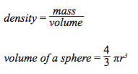

The Kepler mission is particularly concerned with finding planets that lie within the habitable zones of stars. A planet in a star’s habitable zone receives the right amount of energy from the star to maintain liquid water on its surface, provided it also has an appropriate atmosphere.

(e) By comparing the Kepler 20 system and our own solar system, suggest which planet in the Kepler 20 system is most likely to lie in the habitable zone. Explain your answer. (3 marks)

6. A 2.00 x 102 kg satellite is put into a low Earth orbit at an altitude of 3.00 x 102 km.

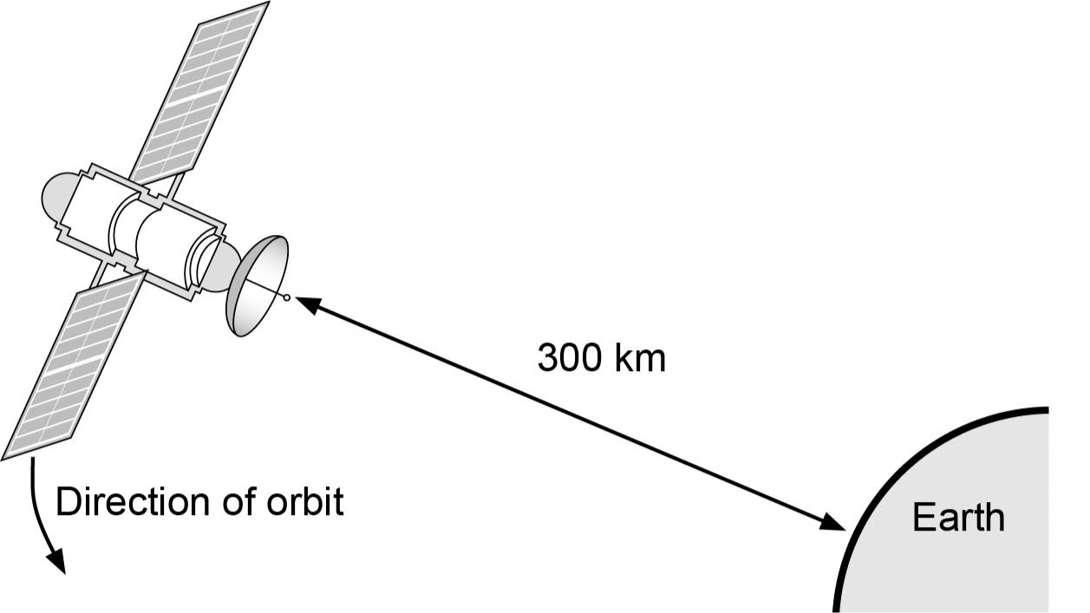page18image15800000

(a) Calculate the orbital speed of the satellite. (3 marks)

(b) Calculate the orbital period of the satellite. (2 marks)

(c) Calculate the gravitational acceleration experienced by the satellite in orbit.

(2 marks)

An amateur astronomer on Earth measures the orbital period of the international space station in the night sky at 94.7 minutes.

(d) Calculate the altitude of the International Space Station based on an orbital period  
 of 94.7 minutes. (3 marks)

7. A group of students wanted to verify Kepler’s laws of planetary motion. They chose to collect data on four moons of Jupiter.

(a) Complete the following table, using the data provided for the moons. (2 marks)

|  |  |  |  |  |
| --- | --- | --- | --- | --- |
| **Moon** | **Orbital radius (r)**  **(×106 m)** | **Orbital period (T)**  **(×103 s)** | **r3**  **(×1024)** | **T2**  **(×109)** |
| Metis | 128 | 25.5 | 2.10 | 0.65 |
| Adrastea | 129 | 25.8 | 2.15 | 0.67 |
| Amalthea | 181 | 43.0 | 5.93 | 1.85 |
| Thebe | 222 | 58.3 |  |  |

(b)   Plot the data from the table above onto the grid provided, demonstrating the relationship described by Kepler’s laws of planetary motion. Draw the line of best fit. (4 marks)

(c)   Using your graph, determine Kepler’s constant (the ratio of *r*3 to *T*2). Express your answer in the appropriate significant figures. (3 marks)

(d) Use your graph to determine the mass of Jupiter. (3 marks)

